Document A

Receipt for Schooling Your Black Girl

(Transcription is modified for length and clarity.)
This is a receipt paid by Elizabeth Crowninshield Derby (wife of Elias Hasket Derby). It is paid to Hannah Masurey for schooling a girl, either from Africa or of African descent, and another girl (presumably white) identified by her name, Betsy Browne.

May 4, 1788
Mrs. Derby to Hannah Masurey Dr. £ s d
to one quarters schooling your Black girl 0 = 9 = 0
to one quarters schooling Betsy Browne 3s . . . 0 = 3 = 0
Received Payment Hannah Masurey

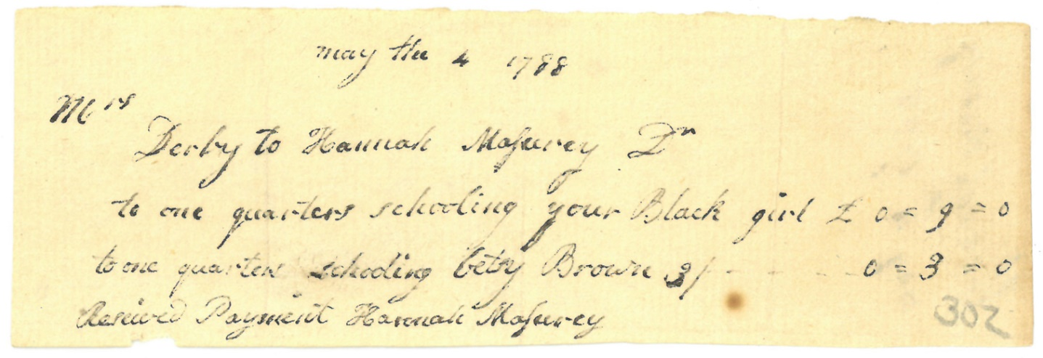

Image Source
Derby Family Papers, MSS37, Box 17 Folder 4
Courtesy of The Phillips Library, Peabody Essex Museum, Salem, Mass.

Vocabulary
- £, s, d: symbols for pounds, shillings, and pence, English currency (money). 20 s is equal to 1 £.

Document B

Receipt for School Rose

(Transcription modified for length and clarity.)
This is a receipt paid by Elizabeth Crowninshield Derby (wife of Elias Hasket Derby). It is paid to Hannah Masurey for schooling Rose, a girl enslaved by the Derby family. This may be the same child mentioned in Document A.

August the 3rd 1788
Mrs. Derby to Hannah Masurey Dr. £ s d
to one quarters schooling Rose - 0 = 9 = 0

August the 14 Received Payment
Hannah Masurey

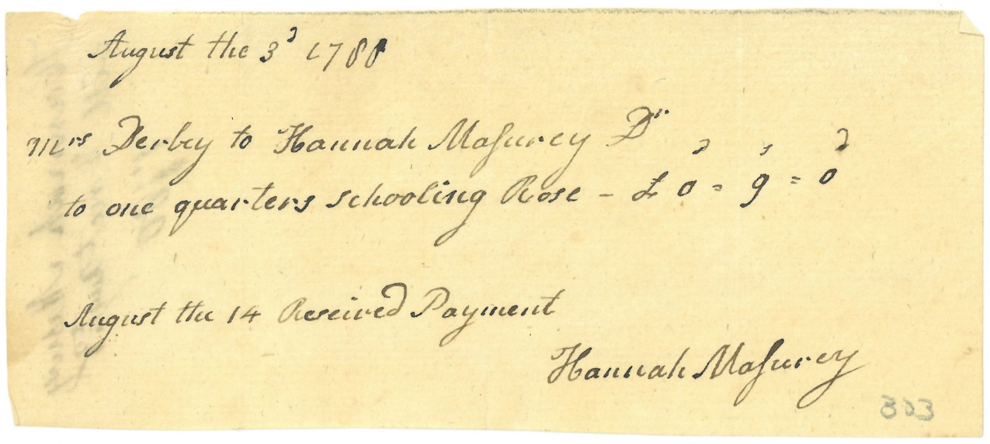

Image Source
Derby Family Papers, MSS37, Box 17 Folder 4
Courtesy of The Phillips Library, Peabody Essex Museum, Salem, Mass.

Document C

Elias Hasket Derby Will

(Transcription modified for length and clarity.)
Elias Hasket Derby, a wealthy and powerful merchant of Salem, died September 8, 1799. In his will, he left money to two enslaved people, Sabe and Rose. However, the money was not given directly to Sabe or Rose, but rather to his daughter Martha. There is evidence of Martha receiving the money (a separate receipt not included here). So far, no evidence has been identified of Sabe or Rose receiving the money described here.

Page 1
I do hereby give my Negro man Saba the sum of two hundred & fifty dollars.
I do hereby give my young Negro woman Rose the sum of two hundred & fifty dollars.

Page 2
And I order and direct my Executor to pay the two last mentioned Legacies given to the said Sabe & Rose unto my daughter Martha; and my will is that my said daughter Martha pay over to Saba & Rose the principal sum and interest in such proportions and at such times, as she may think proper.

Vocabulary
- Executor: the person responsible for settling financial affairs and carrying out the will of a person who has died.
- Will: a legal document with instructions for what to do with a person’s money and property after their death.
- Proportion: a part or share of something rather than the whole.

Document C (page 1)
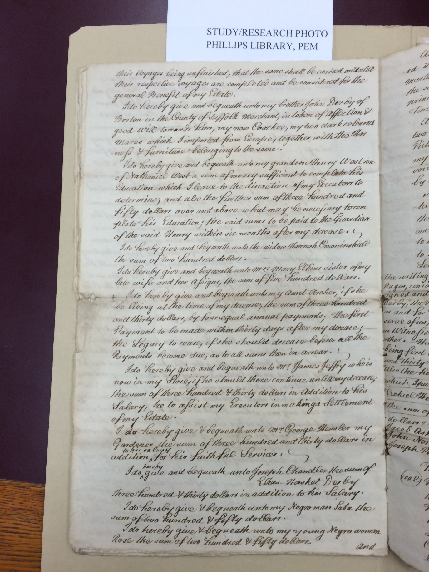
Image Source
Derby Family Papers, MSS37, Box 19 Folder 1
Courtesy of The Phillips Library, Peabody Essex Museum, Salem, Mass.

Document C (page 2)

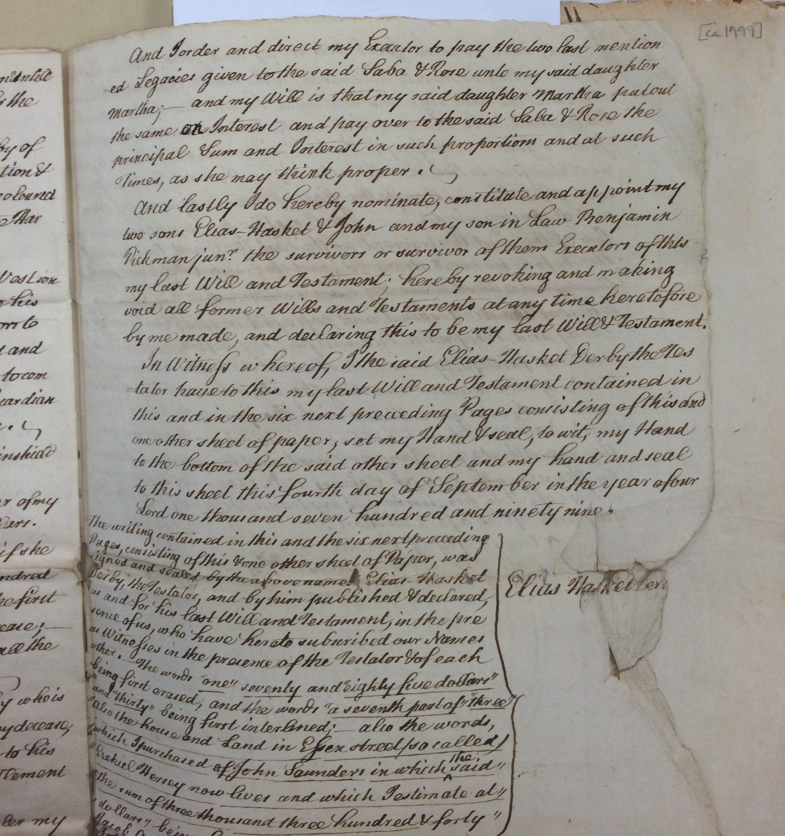

Image Source
Derby Family Papers, MSS37, Box 19 Folder 1
Courtesy of The Phillips Library, Peabody Essex Museum, Salem, Mass.

Document D

Sabe & Rose Marriage

(Transcription modified for length and clarity.)
This is a record of marriages in Salem, 1798-1800. Enslaved people often took on the last names of their enslavers, as Sabe does here. Rose however is identified as “Rose Lane.” Rose and Sabe married in December of 1799, three months and one day after their enslaver, Elias Hasket Derby died.

1799
December 9 Sabe Derby & Rose Lane, Negroes

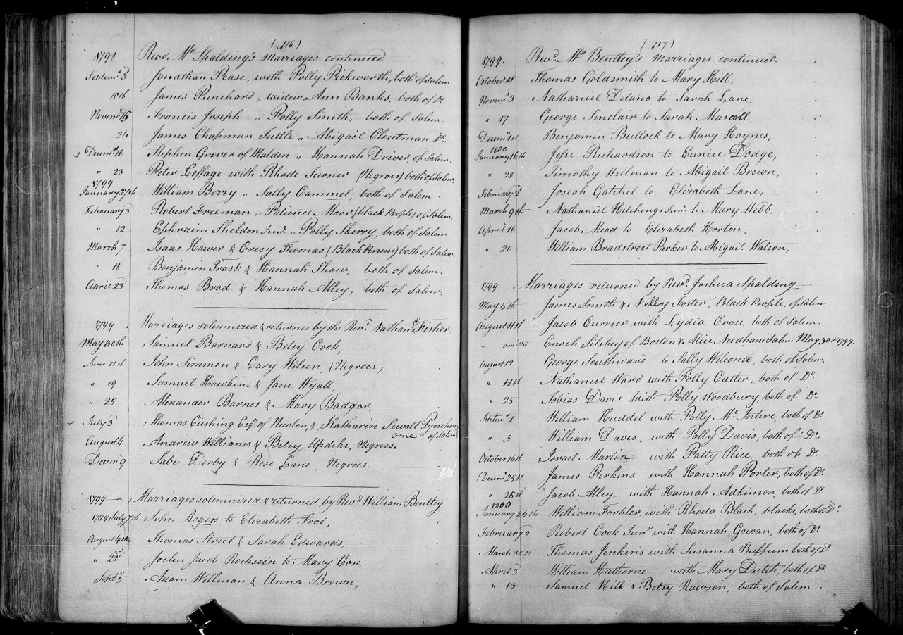
Image Source

Document E

Rose’s Obituary

(Transcription modified for length and clarity.)
This obituary for Rose appeared in the Salem newspaper, The Essex Register, on June 3, 1809.

Rose, wife of Sabe Derby, free blacks, both formerly belonging to Elias Hasket Derby, an eminent merchant of Salem. The good qualities of this woman had gained her just esteem, and the funeral procession last Thursday, did honor to the people of color, from the descent manners and appearance of all who were assembled on the occasion. The friends of humanity are delighted when they see such unequivocal proofs of the good habits and rising hopes of a once oppressed part of civil society.
Vocabulary
- Obituary: a notice of someone’s death, usually in a newspaper.
- Eminent: a well known and (usually) respected person in a certain field or profession.
- Unequivocal: Without a doubt, clear or unmistakable.

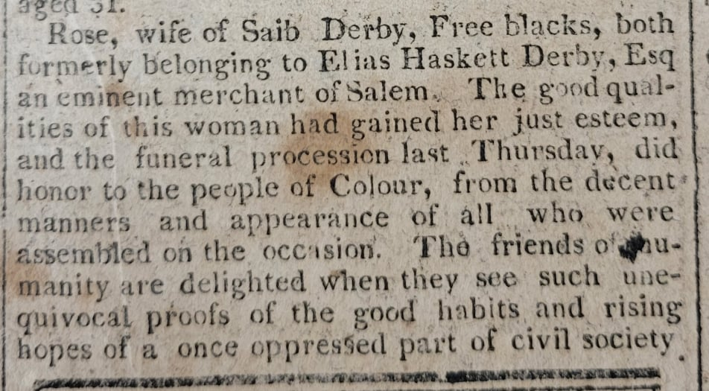

Image Source:
“The Essex Register,” Saturday, June 3, 1809. Museum of Printing, Haverhill, MA. NPS Photo.

Graphic Organizer and Guiding Questions

Vocabulary
- Primary source: evidence (like a document or artifact) created during the time period in which the event was happening.
- Secondary source: a source (like a textbook) that provides information about a subject but is not first-hand evidence (like a primary source.)
 | #1  What type of document is this?  What is its purpose? | #2  When and where is it written? | #3  How is rose referred to/described?
Document A
Document B
Document C
Document D
Document E

#4
What do we know about Rose from the primary source records?

#5
What do we know about her from secondary sources?

#6
What don’t we know?

Write at least three questions you have about Rose.
#7
Is Rose’s story important to understanding Salem’s history?

Explain your opinion.

